ETEC 326 Logbook – Randy Ropan 301019530

February 1st - Creating Schedule:

I created a schedule that laid out the project plan for the Quadcopter using a template I found online. I listed each task name and assigned those specific tasks to the corresponding person in the group. For example, the hardware diagram is assigned to Dmytro, the design/schematics of the drone is assigned to me, the bill of materials is assigned to Van, and the design/schematics of the claw system is assigned to Mohammed. Each task has a start date, end date, duration, priority, and status section displayed below.

|  |  |  |  |  |  |
| --- | --- | --- | --- | --- | --- |
| PROJECT NAME | Quadcopter with Payload System | | | INSTRUCTOR | Mark Thomas |
| PROJECT DELIVERABLE | Functional 5-inch drone w/ modified claw system mounted underneath frame controlled via app from smartphone | | | | |
| SCOPE STATEMENT | Drone will pick up a load to transport and carry by claw system | | | | |
| START DATE | 01/24/2024 | END DATE | 02/18/2024 | OVERALL PROGRESS | 50% |
|  |  |  |  |  |  |

|  |  |  |  |  |  |  |
| --- | --- | --- | --- | --- | --- | --- |
| **TASK NAME** | **ASSIGNED TO** | **START**  **DATE** | **END**  **DATE** | **DURATION**  in days | **PRIORITY** | **STATUS** |
| Initialization | Everyone | 01/17 | 01/24 | 7 | Not Urgent | Completed |
| Review Capstone Project | Everyone | 01/17 | 01/24 | 7 | Not Urgent | Completed |
| Research Components | Everyone | 01/24 | 02/03 | 10 | Critically Urgent | Completed |
| Hardware Diagram | Dmytro | 01/31 | 02/13 | 13 | Important | In Progress |
| Software Diagram | Dmytro | 01/31 | 02/13 | 13 | Important | In Progress |
| Schematic/Design of Drone | Randy | 01/31 | 02/13 | 13 | Critically Important | In Progress |
| Schedule/WBS Structure | Randy | 01/31 | 02/13 | 13 | Important | In Progress |
| Technical Specifications | Van | 01/31 | 02/13 | 13 | Critically Important | In Progress |
| Bill of Materials | Van | 01/31 | 02/13 | 13 | Important | In Progress |
| Schematic of Claw System | Abraar | 01/31 | 02/13 | 13 | Important | In Progress |
| Budget | Dmytro, Randy | 02/01 | 02/13 | 12 | Important | Completed |
| Purchasing Components | Dmytro | 02/05 | 02/07 | 2 | Important | Completed |
| Hardware Assembly | Everyone | 02/19 | 02/23 | 5 | Important | Not Yet |
| 3D Print Claw System | Dmytro, Abraar | TBA | TBA | TBA | Important | Not Yet |
| Programming | Dmytro | TBA | TBA | TBA | Not Urgent | Not Yet |
| Project Test/Functionality | Everyone | TBA | TBA | TBA | Not Urgent | Not Yet |
| Records of Documentation | Everyone | TBA | TBA | TBA | Not Urgent | Not Yet |
| Finalization of Project | Everyone | TBA | TBA | TBA | Not Urgent | Not Yet |

February 3rd - Work Breakdown Structure (WBS):

**Quadcopter Project WBS February 1st-13th**

|  |  |  |
| --- | --- | --- |
| **Phase** | **WBS** | **Task Description** |
| 1. | **1.1 Initialization** | 1.1.1 Review Capstone Project |
| 1.1.2 Scope Statement |
| 1.1.3 Research Components |
| 1.1.4 Project Approval |
| 2. | **1.2 Planning** | 1.2.1 Schedule |
| 1.2.2 Hardware Diagram |
| 1.2.3 Software Diagram |
| 1.2.4 Drone Schematic & Design |
| 1.2.5 Claw System Schematic & Design |
| 1.2.6 Budget |
| 1.2.7 Technical Specifications |
| 1.2.8 Bill of Materials |
| 1.2.9 Purchasing Components |
| 3. | **1.3 Executing** | 1.3.1 3D Print Claw System |
| 1.3.2 Hardware Assembly |
| 1.3.3 Soldering |
| 1.3.4 Programming |
| 1.3.5 Inspection |
| 4. | **1.4 Control** | 1.4.1 Time Management |
| 1.4.2 Cost Management |
| 1.4.3 Risk Management |
| 1.4.4 Quality Management |
| 5. | **1.5 Closeout** | 1.5.1 Cleanup |
| 1.5.2 Functionality Test |
| 1.5.3 Records of Documentation |
| 1.5.4 Submission |

February 4th -Responsibility Assignment Matrix (RAM):

Legend:

**R** = **Responsible:** Person who is completing the task

**A** = **Accountable:** Person who is making decisions and taking actions on the task(s)

**C** = **Consulted:** Person who will be communicated with regarding the decision-making process and specific tasks

**I** = **Informed:** Person who will be updated on decisions and actions during the project

|  |  |  |  |  |  |
| --- | --- | --- | --- | --- | --- |
| Deliverable | Task | Randy | Dmytro | Van | Mohammed |
| **1.1 Initialization** | Review Capstone Project | **R** | **R** | **R** | **R** |
| Scope Statement | **C** | **R** | **I** | **I** |
| Research Components | **R** | **A** | **R** | **C** |
| Project Approval | **I** | **A** | **I** | **I** |
| **1.2 Planning** | Scheduling | **R** | **A** | **C** | **C** |
| Hardware Diagram | **A** | **R** | **C** | **A** |
| Software Diagram | **C** | **R** | **A** | **C** |
| Drone Schematic & Design | **R** | **A** | **I** | **C** |
| Claw System Schematic & Design | **I** | **A** | **C** | **R** |
| Budget | **I** | **R** | **I** | **I** |
| Technical Specifications | **A** | **C** | **R** | **A** |
| Bill of Materials | **C** | **I** | **R** | **I** |
| Purchasing Components | **C** | **R** | **C** | **C** |
| **1.3 Executing** | 3D Print Claw System | **C** | **A** | **C** | **R** |
| Hardware Assembly | **R** | **R** | **R** | **R** |
| Soldering | **R** | **R** | **A** | **A** |
| Programming | **A** | **R** | **I** | **C** |
| Inspection | **A** | **I** | **R** | **R** |
| **1.4 Control** | Time Management | **R** | **I** | **I** | **I** |
| Cost Management | **I** | **R** | **I** | **I** |
| Risk Management | **I** | **I** | **R** | **I** |
| Quality Management | **I** | **I** | **I** | **R** |
| **1.5 Closeout** | Cleanup | **R** | **R** | **R** | **R** |
| Functionality Test | **A** | **R** | **R** | **A** |
| Records of Documentation | **R** | **R** | **R** | **R** |
| Submission | **C** | **R** | **C** | **C** |

February 5th - Hand Drawn Schematic:

I started the design/schematics of the drone. I looked at designs online to get an idea of what kind of design we wanted to do. We settled for a traditional ‘X’ frame design. The frame model shown below is called the “**TBS SOURCE ONE V5”** and it’s 5 inches in length. I did a hand drawn schematic of the drone design based off this model from the top view. The flight controller, ESC, receiver, battery, and antenna are located inside the frame. We plan on 3D printing the propellors.

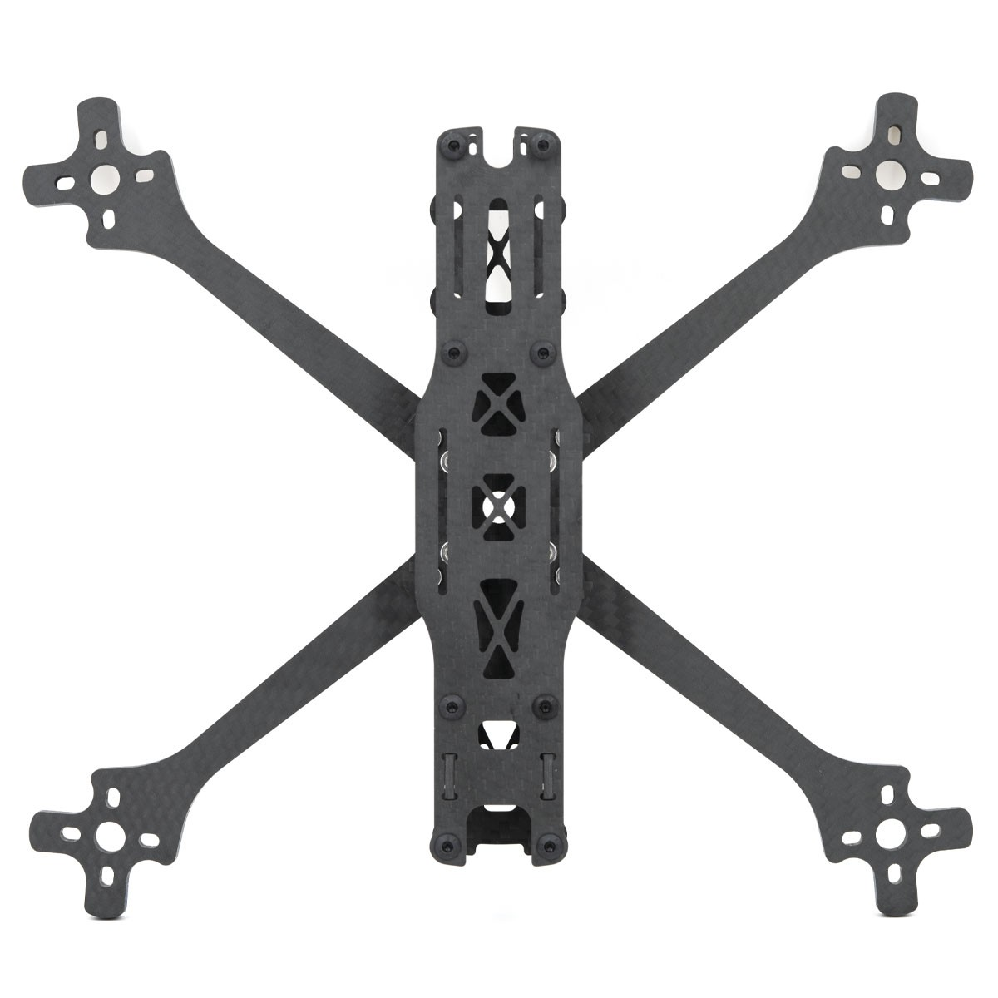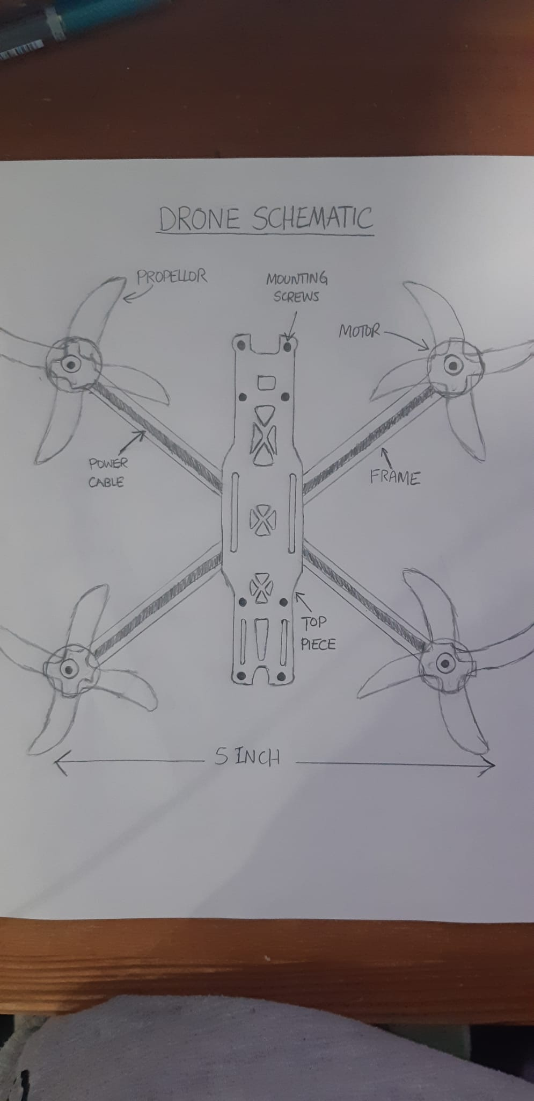

February 7th - Software for Drone:

My group joined the zoom meeting with John and Mike in class to discuss software that can control the drone using a phone. John recommended a website that utilizes third party software. It is a GitHub link that shows possible ways of controlling a drone via phone. We did research on how to control a drone using a phone and found a few YouTube videos.

John and Mike also recommended buying the propellors off the shelf because 3D-printing them can cause problems in terms of size, durability and functionality. So, we decided to scrap 3D printing them. Now we will have to find suitable propellors that can fit our build.

**NOTE: Scrapped 3D printing propellors, decided to purchase them instead**

February 9th - Digital Schematic:

I created a new schematic digitally using Microsoft 3D Paint. I labelled each component in the diagram to give us a better idea of the project’s assembly.

**NOTE: We are not using an FPV Camera in our build due to budget constraints**

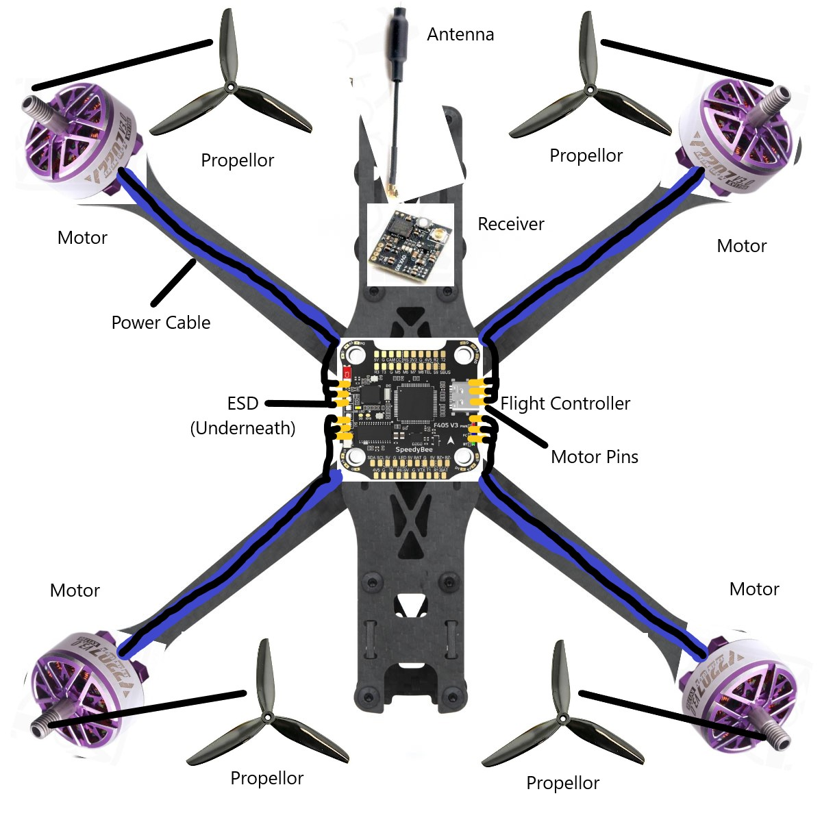

February 10th -Flight Controller Schematic:

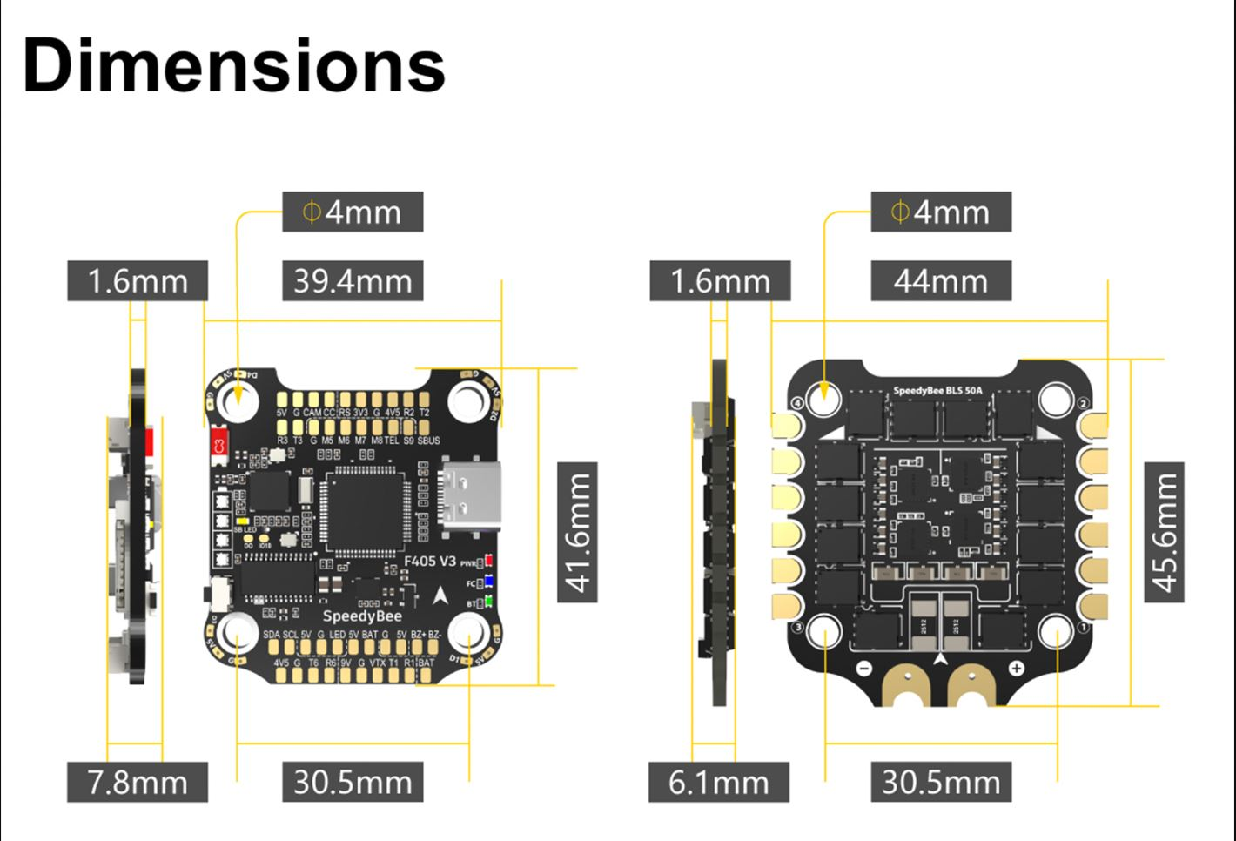

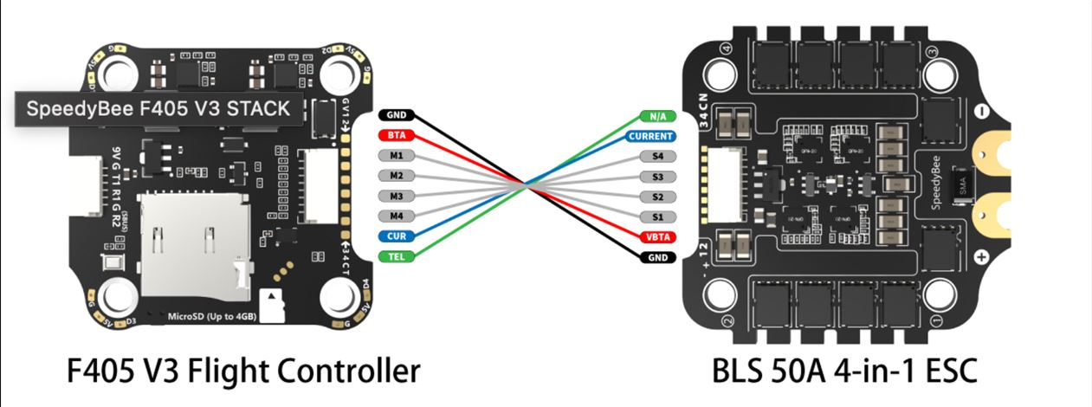

**Front:**

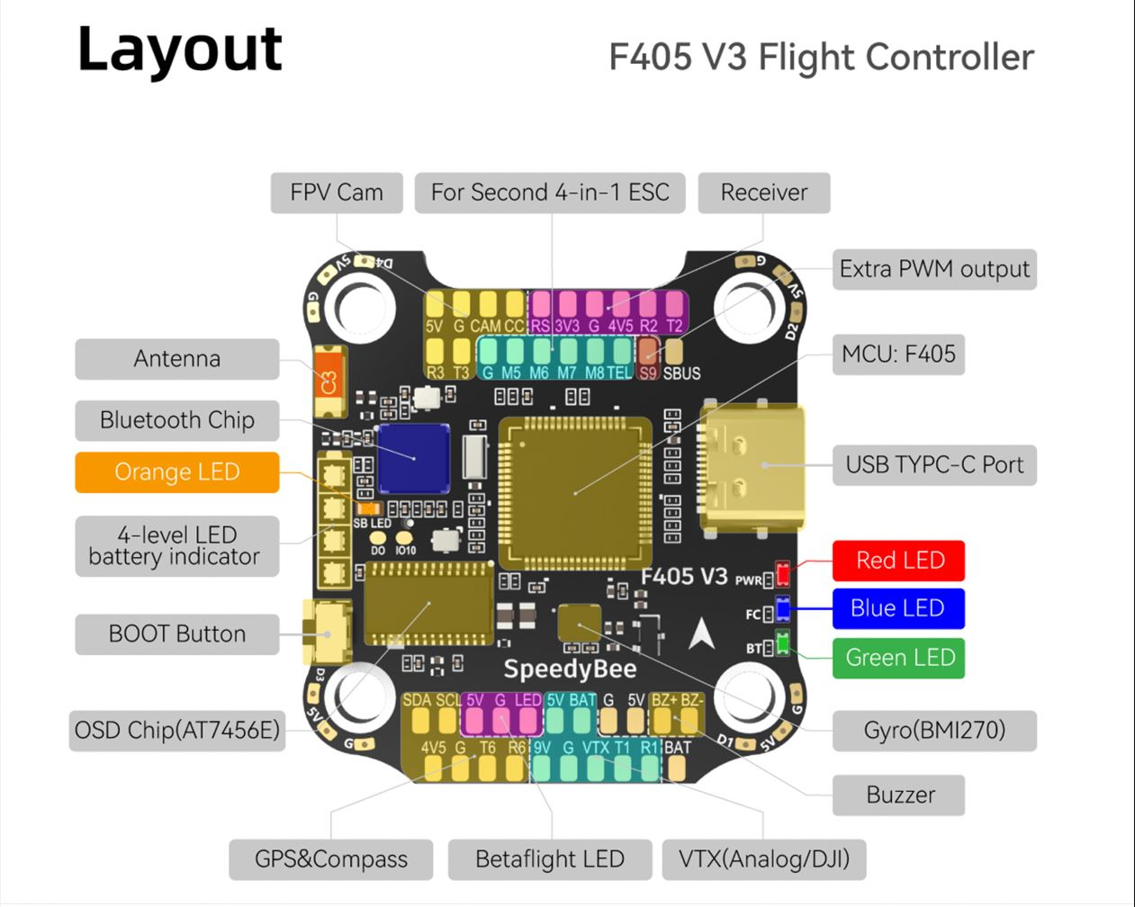

**Back:**

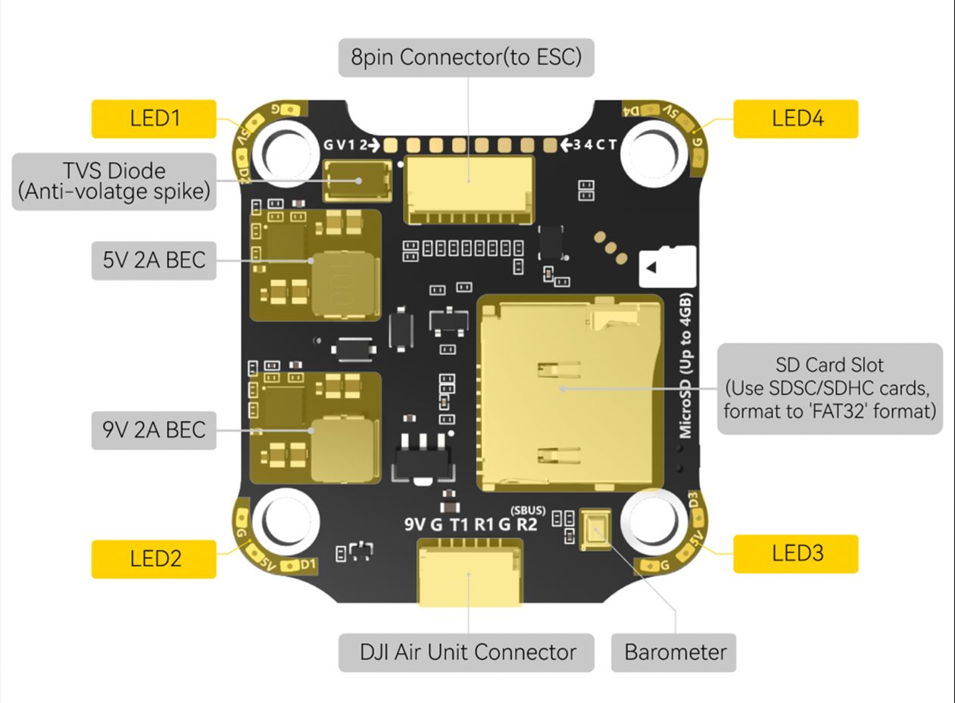

**ESD Schematic:**

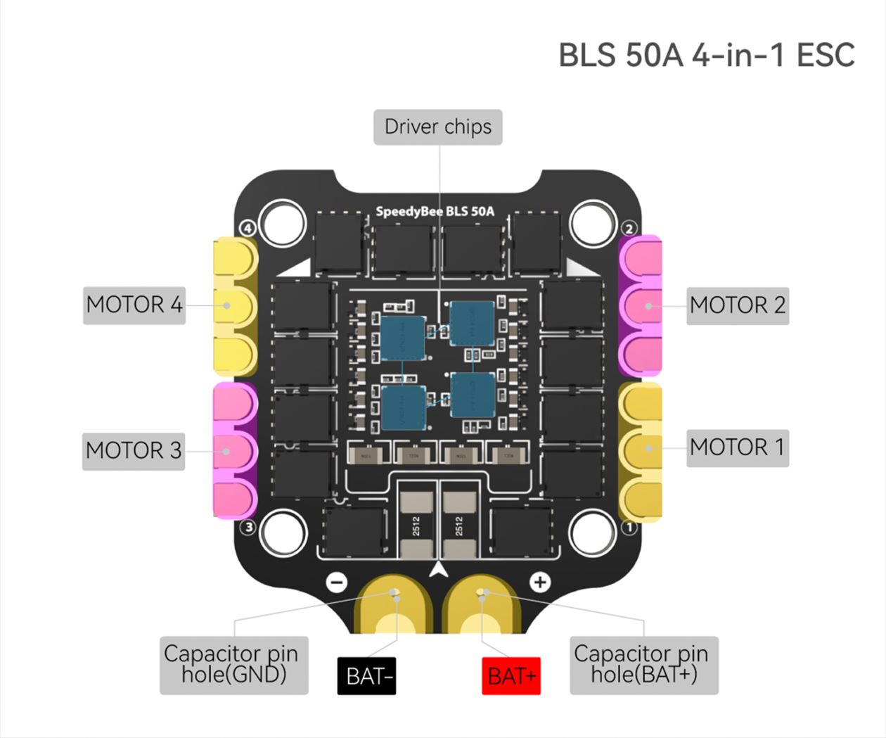

**Wiring Diagram:**

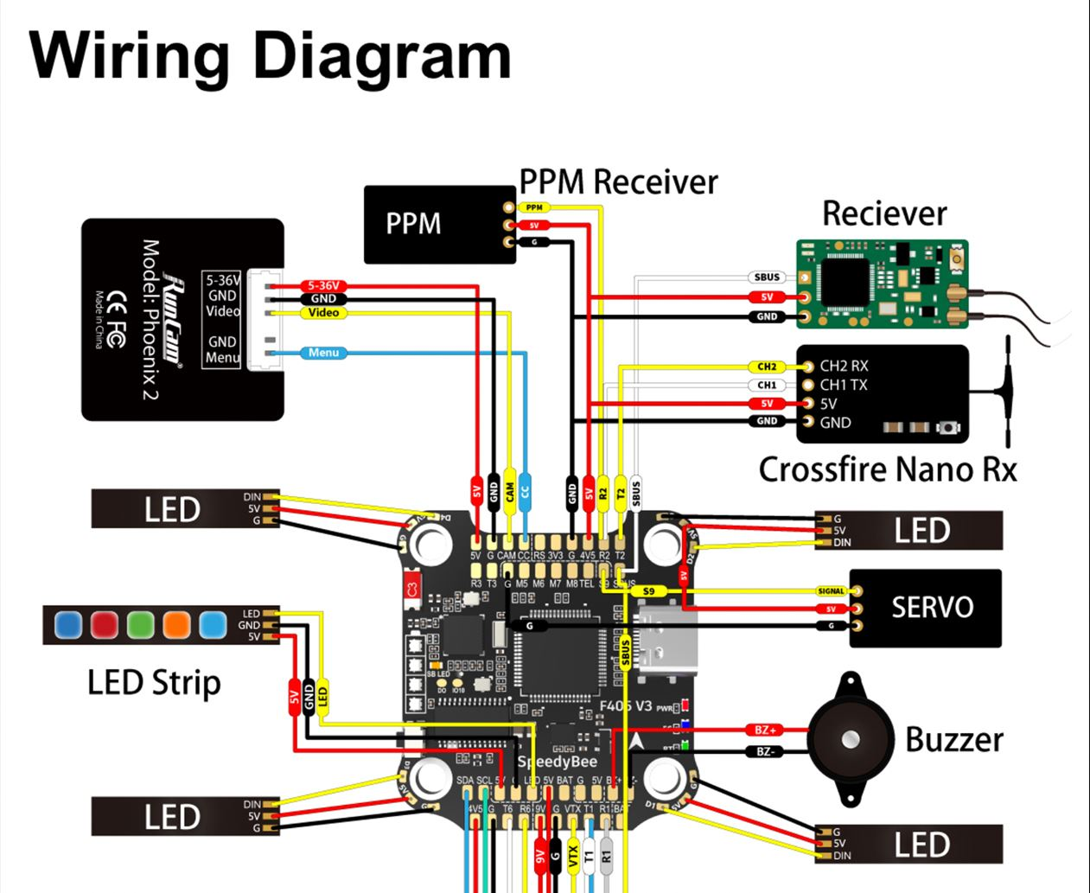

February 15th – Software to Control Drone:

I did some research on how to control the drone using a phone and apparently SpeedyBee offers their own app called “SpeedyBee”. However, this app is only used to configure the settings for the motors, sensors, gyroscope, accelerometer, GPS, etc. The best option I came across was the link John provided in one of our meetings called “QGroundControl”. It is software that fully enables flight control using MAVLink protocols. QGC is available on Windows, OS X, Linux, iOS, and Android devices.